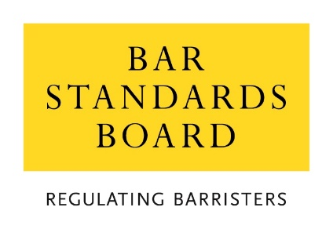 | Inn’s Logo

Application for Temporary Admission and Call
As a Qualified Foreign Lawyer

Please complete all sections of the information form and the admission and Call Declaration which follows it.

How will my information be handled?
Your data will be processed in accordance with the Inn’s data protection policy for the administration of its membership records and to achieve its obligations as set out in a Memorandum of Understanding (MoU) agreed with the Bar Standards Board, Council of the Inns of Court and the Inns of Court. If you would like more information on the legal basis for the processing of your information by the Inn, please see the Inn’s privacy statement.

The Inn shares information with the Bar Standards Board for the stated purposes set out in the data sharing protocol which forms part of the MoU. For more information on how the Bar Standards Board uses your information, whether obtained from the Inn or otherwise, please read their privacy statement.

What should I do if I want help in completing this application?
We are committed to ensuring that everybody finds it easy to communicate with us and to complete this application. We will make reasonable adjustments so that people with disabilities find it easy to complete any forms relating to their admission and Call and any ongoing matters related to their membership. If you require this document in a different format, please contact the Inn.

When submitting the information form and Declaration please also include the following:
- The original or a certified copy of your Temporary Qualification Certificate, issued by the Bar Standards Board
- A certified copy of your ID (passport, driving licence or national ID card)
- Any fee (if applicable).

Information Form

Title
First name
Middle name(s)
Surname
Date of birth

Home address
Professional address
Contact telephone number
Mobile number
Email address

List of case(s) that are covered by your Temporary Qualification Certificate
The date the case(s) are estimated to commence and conclude

Declaration for Temporary Admission and Call
As a Qualified Foreign Lawyer

To the Masters of the Bench of the Honourable Society of _________________________:
I, (full name) ……………………………………………………………………………………….…
of (address) ……………………………………………………………………………….…………
……………………………………………………… ……………………………
for the purpose of being admitted as a member of the Inn and Called to the Bar on a temporary basis do hereby declare and undertake as follows:

- I am a member of ..........................................................................................
- The information which I have provided in support of my application to be admitted as a member of the Inn and Called to the Bar is true to the best of my knowledge and belief.
- The information that I have provided to the Bar Standards Board in relation to my application for a Temporary Qualification Certificate is true to the best of my knowledge and belief.
- So long as I remain a barrister of England and Wales, I will comply with the Bar Standards Board Handbook or any equivalent publications that replace it.
- I will not at any time hold myself out or allow myself to be held out as a barrister of England and Wales nor will I exercise any right that I have by reason of being a barrister of England and Wales other than in connection with the case or cases which I have been authorised by the Bar Standards Board to conduct as a barrister of England and Wales.
- I understand that I will automatically cease to be a barrister of England and Wales and a member of the Inn on conclusion of the case or cases which I have been authorised by the Bar Standards Board to conduct as a barrister of England and Wales. I will inform the Inn and the Bar Standards Board as soon as the case or cases have ended.
- I understand that if this declaration or any other information provided in support of my application is found to have been false in any material respect, or if I breach any undertaking given in it in any material respect, then that will constitute professional misconduct and a breach of the Bar Standards Board Handbook. I further understand that if this declaration or any other information provided in support of my application is found to have been false in any material respect, or if I breach any undertaking given in it in any material respect, then the Bar Standards Board shall refer such matters to the applicant’s home regulator to be dealt with under their jurisdiction as appropriate.
- I confirm that should any information within this declaration change prior to my being Called to the Bar of England and Wales, I will notify the Inn.

Signed ……………………………… Dated …………………

Specify the legal profession regulated in a jurisdiction outside England and Wales of which you are a member.
You must inform the Inn and the Bar Standards Board Records Team as promptly as possible.

