Application for Reduction in Pupillage for a Barrister who has also qualified as a Solicitor

1. Personal Details

Surname

Other names

Title

(eg Mr, Ms)

Address
Telephone no.

Email address

Inn of Court

Date of Call to the Bar

2. Pupillage

Please give details of any pupillage already completed
 | Chambers / PTO / AETO | Dates
Non-practising period (“first six”)
Practising period (“second six”)

3. Training Contract
Please give details of either your training contract, or experience accepted by the Law Society/Solicitors Regulation Authority in lieu of a training contract

Firm/Organisation | Dates

4. Date of Admission to the Roll of Solicitors

5. Rights of Audience

If you have been granted higher court rights by the Law Society, please give details of the date on which these were granted and whether they are in civil or criminal proceedings or both. If you have higher court rights in civil or in criminal proceedings only, please indicate whether you intend only to practise in such proceedings as a barrister.

6. Post-Qualification Experience

Dates | Employer | Brief Description of Work

7. Relevant Experience

Please give full details of your practice as a solicitor to date and how you feel it has prepared you for practice as a barrister. In particular, please give details of any advocacy experience, including the range of courts in which you have appeared, the frequency with which you have done so and over what period of time.

Please continue on a separate sheet if required

8. Practice as a Barrister

Please explain why you wish to join the Bar and your intentions regarding practice. Please supply details of any pupillage, tenancy or other position as a barrister that you have been offered.

9. Declaration

I declare that*:

i) I have not on the ground of professional misconduct or the commission of any criminal offence been prohibited from practising in any jurisdiction in which I have been admitted as a solicitor and I am not currently suspended from so practising;

ii) No bankruptcy order or directors disqualification order has been made against me and I have not entered into an individual voluntary arrangement with my creditors;

iii) I am not aware of any circumstances which might lead to an event falling within (i) or (ii) above taking place;

iv) The information that I have provided is complete and accurate;

v) Any supporting evidence that I have supplied with this application that refers to third parties has been suitably redacted so as to preserve their anonymity;

vi) I have read the Bar Council’s Privacy Statement and understand how my data will be handled.

*If you are unable to make any part of this declaration, please delete
that part clearly and provide full details on a separate sheet.

Signature

Date

CHECKLIST

Please enclose with this form:

i) Original Certificate of Good Standing issued by the Law Society of England and Wales or the Law Society of Northern Ireland, not more than 3 months old at the date of receipt of the application to the Bar Standards Board.

ii) Original Certificate of Higher Court Rights (where appropriate)

iii) Any other evidence which you wish to supply in support of your application (e.g. references)

iv) Current application fee. Please refer to the guidance notes for the appropriate fees and payment method.

Please confirm how you wish your original documents to be returned:

□ I wish for my documents to be returned in the pre-paid self-addressed envelope provided by me.

□ I wish for my documents to be returned normal post.

Please note: Your application cannot be processed until you have provided all of the evidence in the required format; furthermore, it is your responsibility to ensure that this accompanies your application.

Please send the form, with all supporting documentation, to:

The Authorisations Team
Regulatory Operations Department
The Bar Standards Board
289-293 High Holborn
London
WC1V 7HZ

DX 240 LDE

authorisations@barstandardsboard.org.uk

The fee is non-refundable.
 | 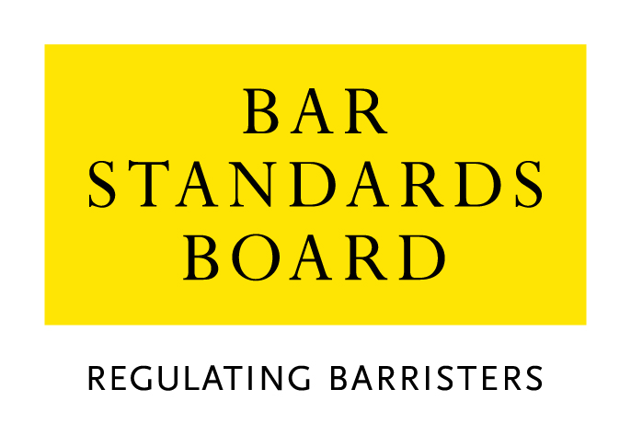

Equality & Diversity Monitoring Form

Diversity data gathered from this form will be anonymised and used to inform Bar Council and Bar Standards Board (BSB) policy aimed at widening access to the profession and improving diversity. It will assist the Bar Council and BSB in meeting our statutory duties under the Equality Act 2010 and will inform our wider equality and diversity strategy.

Your diversity data will be treated as confidential and stored securely according to the Bar Council’s Privacy policy. It will not be published in a way which might identify any individual. The raw data will be kept only for monitoring purposes.

Question formats are based on LSB approved monitoring questions.

Provision of diversity information is not compulsory however we strongly encourage you to help us by completing this form.

Please answer each question in turn by choosing one option only, unless otherwise indicated. If you do not wish to answer the question please choose the option ‘Prefer not to say’ rather than leaving the question blank.

1. Age

From the list of age bands below, please indicate the category that includes your current age in years:

16 - 24
25 - 34
35 - 44
45 - 54
55 - 64
65+
Prefer not to say

2. Gender

What is your gender?

Male
Female
Prefer not to say

3. Disability

The Equality Act 2010 generally defines a disabled person as someone who has a mental or physical impairment that has a substantial and long-term adverse effect on the person’s ability to carry out normal day-to-day activities.

(a) Do you consider yourself to have a disability according to the definition in the
Equality Act?

Yes
No
Prefer not to say

(b) Are your day-to-day activities limited because of a health problem or disability which has lasted, or is expected to last, at least 12 months?

Yes, limited a lot
Yes, limited a little
No
Prefer not to say

4. Ethnic group

What is your ethnic group?

Asian / Asian British

Bangladeshi
Chinese
Indian
Pakistani
Any other Asian background (write in)

Black / African / Caribbean / Black British

African
Caribbean
Any other Black / Caribbean / Black British (write in)

Mixed / multiple ethnic groups

White and Asian
White and Black African
White and Black Caribbean
White and Chinese
Any other Mixed / multiple ethnic background (write in)

White

British / English / Welsh / Northern Irish / Scottish
Irish
Gypsy or Irish Traveller
Any other White background (write in)

Other ethnic group

Arab
Any other ethnic group (write in)

Prefer not to say

Prefer not to say
5. Religion or belief

What is your religion or belief?

No religion or belief
Buddhist
Christian (all denominations)
Hindu
Jewish
Muslim
Sikh
Any other religion (write in)
Prefer not to say

6. Sexual orientation

What is your sexual orientation?

Bisexual
Gay man
Gay woman/lesbian
Heterosexual/straight
Other
Prefer not to say

7. Socio-economic background

(a) If you went to University (to study a BA, BSc course or higher), were you part of the first generation of your family to do so?

Yes
No
Did not attend University
Prefer not to say

(b) Did you mainly attend a state or fee paying school between the ages 11 – 18?

UK State School
UK Independent/Fee-paying School
Attended school outside the UK
Prefer not to say

8. Caring responsibilities

(a) Are you a primary carer for a child or children under 18?

Yes
No
Prefer not to say

(b) Do you look after, or give any help or support to family members, friends, neighbours or others because of either:

- Long-term physical or mental ill-health / disability
- Problems related to old age?

(Do not count anything you do as part of your paid employment)

No
Yes, 1 - 19 hours a week
Yes, 20 - 49 hours a week
Yes, 50 or more hours a week
Prefer not to say

Thank you for completing this questionnaire

See https://www.barstandardsboard.org.uk/privacy-statement.html

