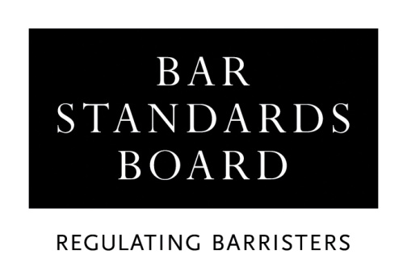

APPLICATION FOR A CERTIFICATE OF ACADEMIC STANDING

Before completing and submitting this form, you must read the accompanying guidelines in full, together with the Checklist.

Your application cannot be processed until we have received all necessary supporting documents in the format specified in the application guidelines, and you have either paid the application fee or submitted a request for a fee waiver or instalment plan.

Please complete this form using type or uppercase letters.

All dates should be entered in full: ie 00/00/00.

APPLICANT DETAILS
Title: Miss / Mr / Mrs / Ms (delete as appropriate)

Full name:

(Please underline family name/surname)

Address:

Telephone no.
Email address:

If you have completed (or applied to undertake) a GDL course, please complete this section.

Full-time/part-time/distance learning (delete as appropriate)

Start date:

Actual/Expected end date:

Institution:

NATURE OF APPLICATION
- If you are applying based on academic qualifications, please complete Section A of this application form

- If you are applying based on alternative qualifications and/or experience, please complete Section B of this application form

- If you wish to rely on both academic qualifications and alternative qualifications and/or experience, please complete all sections of this application form

SECTION A – ACADEMIC QUALIFICATIONS

Please provide transcripts for listed qualifications. We will accept copies of academic transcripts or professional confirmations emailed directly from the awarding body/regulator. If you are unable to provide documents by this method, please submit scans of your personal copies. We may contact the awarding body/regulator of any scanned documents provided directly by you to verify their content.

UK and Republic of Ireland degrees

If you hold an undergraduate or postgraduate degree awarded by a university in the UK/Republic of Ireland, please enter the details below:

Degree Title | Honours/  Ordinary | Subject | Class/  Grade | Institution(s) | Dates: From/To

Overseas degrees

If you hold an undergraduate or postgraduate degree awarded by a university outside the UK/Republic of Ireland, please enter the details below:

Degree Title | Subject | Class/  Grade | Institution Title & Country | Dates:  From/To

Professional qualifications

If you hold any professional qualifications, or further academic qualifications, please enter the details below:

Qualification Title and Awarding Body | Subject(s) | Grade | Dates: From/To

SECTION B – ALTERNATIVE QUALIFICATIONS AND/OR EXPERIENCE
Academic qualifications (do not enter degree qualifications in this section)

If you are applying based on alternative qualifications and/or experience, you must enter the details of all Ordinary Level passes achieved in the examination for the General Certificate of Secondary Education (GCSE), and all Ordinary and Advanced Level passes achieved in the examination for the General Certificate of Education (GCE), below. One Ordinary Level pass should be in English Language. If you hold any General National Vocational Qualifications (GNVQ) / Business & Technology Education Council (BTEC) qualifications, you must enter the details of these below.

Examination Title | Subject(s) | Grade | Date

Professional qualifications

If you hold any professional qualifications, or further academic qualifications, please enter the details below:

Qualification Title and Awarding Body | Subject(s) | Grade | Dates: From/To

Work experience

The Bar Standards Board may, exceptionally, allow applicants who do not hold an undergraduate law degree awarded in England and Wales to undertake a Graduate Diploma in Law course for completion of the academic component of training. It may do so where it is satisfied that an applicant has demonstrated those competences of the Bar Standards Board’s Professional Statement for barristers that are ordinarily demonstrated through possession of an undergraduate law degree (for example, the ability to apply effective analytical and evaluative skills).

An applicant must be able to evidence in their application how they achieved the relevant competences, with examples from their qualifications and/or experience.

Please set out below how you believe you meet these criteria.

Referees

If you are applying based on alternative qualifications and/or experience, please use this space to give full details of all referees who will be supporting your application. Please note that we do not accept references from family members and that references in support of your application must be full, informative and in the referee’s own words.

Although there is no minimum/maximum number of references required, please be selective.

The BSB will not contact referees. References can be emailed directly to us at authorisations@BarStandardsBoard.org.uk by referees or submitted in hard-copy in a sealed envelope.

DECLARATION

I declare that:
- I have read the application criteria and guidelines;
- The information that I have provided is complete and accurate;
- Any supporting evidence that I have supplied with this application that refers to third parties has been suitably redacted so as to preserve their anonymity;
- I am submitting this application with the intention of undertaking the academic component of training for the Bar, and;
- I have read the Bar Council’s Privacy Statement and understand how my data will be handled.

Signature
Name
Date

PLEASE RETURN THE COMPLETED APPLICATION FORM WITH ACCOMPANYING DOCUMENTATION AND PAYMENT OF THE APPLICATION FEE TO:

authorisations@barstandardsboard.org.uk

Alternatively, the completed application form can be posted to:

THE AUTHORISATIONS TEAM, REGULATORY OPERATIONS DEPARTMENT, THE BAR STANDARDS BOARD, 289-293 HIGH HOLBORN, LONDON WC1V 7HZ

The application fee is non-refundable.

You must now refer to the Checklist.

Checklist

A student is not eligible to commence the vocational component of Bar training (ie a Bar Training Course) unless and until that student has satisfactorily completed the academic component or has been granted a waiver to commence the vocational component by the Bar Standards Board. To ensure that this requirement is met, applicants must submit their completed application form at least eight weeks before the proposed enrolment date. We will not be able to expedite applications received less than eight weeks before the proposed enrolment date.

Before returning this form, you must ensure that you have:

- Provided a certified copy (see application guidelines) of the relevant documentation if, for any reason, you have changed your family name/surname by either marriage or statutory declaration since your qualification(s) were awarded;

- Enclosed evidence of all academic and professional qualifications listed on this application which must be in the form of official certificate(s) and transcript(s). You must refer to the certificates and transcripts sections of the application guidelines before submitting either. If necessary, it is acceptable for you to request that these documents are sent directly to the Bar Standards Board (BSB) by the awarding institution; however, the BSB will not contact third parties for this, or any other purpose;

- In the case of overseas qualifications, enclosed an official, English translation of the certificate(s) and transcript(s) where these documents are in a language other than English. You must refer to the application guidelines for further information regarding translations;

- Where appropriate, provided the additional evidence requested under the ‘Particular Degree Qualifications’ section of the application guidelines;

- If applying based on alternative qualifications and/or experience, enclosed a current and detailed Curriculum Vitae and provided professional referees. References from family members are not acceptable;

- Completed and dated the application form. The form may be submitted in hard-copy or by email; however, you must sign the application declaration by hand, as typed signatures are not acceptable;

- Completed the Equal Opportunities Monitoring form (if willing to do so), and;

- Provided payment of the fee of £200.00. Please refer to the current application guidelines for details of acceptable payment methods.

Unless specifically requested by ticking one of the boxes below, any documents provided in support of an application will be destroyed through the Bar Standards Board’s confidential waste procedures.

□ I wish for my documents to be returned in the pre-paid self-addressed envelope provided by me

□ I wish for my documents to be returned by ordinary post

 | 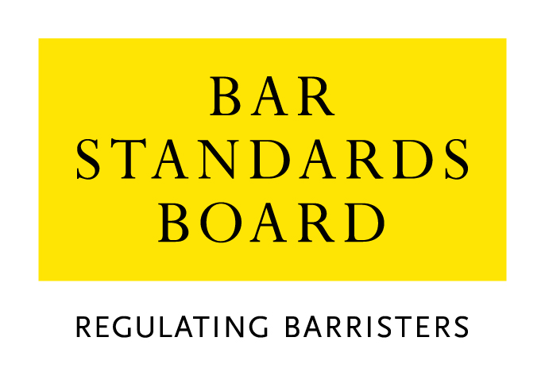

Equality & Diversity Monitoring Form

Diversity data gathered from this form will be anonymised and used to inform Bar Council and Bar Standards Board (BSB) policy aimed at widening access to the profession and improving diversity. It will assist the Bar Council and BSB in meeting our statutory duties under the Equality Act 2010 and will inform our wider equality and diversity strategy.

Your diversity data will be treated as confidential and stored securely according to the Bar Council’s Privacy policy. It will not be published in a way which might identify any individual. The raw data will be kept only for monitoring purposes.

Question formats are based on LSB approved monitoring questions.

Provision of diversity information is not compulsory however we strongly encourage you to help us by completing this form.

Please answer each question in turn by choosing one option only, unless otherwise indicated. If you do not wish to answer the question please choose the option ‘Prefer not to say’ rather than leaving the question blank.

1. Age

From the list of age bands below, please indicate the category that includes your current age in years:

16 - 24
25 - 34
35 - 44
45 - 54
55 - 64
65+
Prefer not to say

2. Gender

What is your gender?

Male
Female
Prefer not to say

3. Disability

The Equality Act 2010 generally defines a disabled person as someone who has a mental or physical impairment that has a substantial and long-term adverse effect on the person’s ability to carry out normal day-to-day activities.

(a) Do you consider yourself to have a disability according to the definition in the
Equality Act?

Yes
No
Prefer not to say

(b) Are your day-to-day activities limited because of a health problem or disability which has lasted, or is expected to last, at least 12 months?

Yes, limited a lot
Yes, limited a little
No
Prefer not to say

4. Ethnic group

What is your ethnic group?

Asian / Asian British

Bangladeshi
Chinese
Indian
Pakistani
Any other Asian background (write in)

Black / African / Caribbean / Black British

African
Caribbean
Any other Black / Caribbean / Black British (write in)

Mixed / multiple ethnic groups

White and Asian
White and Black African
White and Black Caribbean
White and Chinese
Any other Mixed / multiple ethnic background (write in)

White

British / English / Welsh / Northern Irish / Scottish
Irish
Gypsy or Irish Traveller
Any other White background (write in)

Other ethnic group

Arab
Any other ethnic group (write in)

Prefer not to say

Prefer not to say
5. Religion or belief

What is your religion or belief?

No religion or belief
Buddhist
Christian (all denominations)
Hindu
Jewish
Muslim
Sikh
Any other religion (write in)
Prefer not to say

6. Sexual orientation

What is your sexual orientation?

Bisexual
Gay man
Gay woman/lesbian
Heterosexual/straight
Other
Prefer not to say

7. Socio-economic background

(a) If you went to University (to study a BA, BSc course or higher), were you part of the first generation of your family to do so?

Yes
No
Did not attend University
Prefer not to say

(b) Did you mainly attend a state or fee paying school between the ages 11 – 18?

UK State School
UK Independent/Fee-paying School
Attended school outside the UK
Prefer not to say

8. Caring responsibilities

(a) Are you a primary carer for a child or children under 18?

Yes
No
Prefer not to say

(b) Do you look after, or give any help or support to family members, friends, neighbours or others because of either:

- Long-term physical or mental ill-health / disability
- Problems related to old age?

(Do not count anything you do as part of your paid employment)

No
Yes, 1 - 19 hours a week
Yes, 20 - 49 hours a week
Yes, 50 or more hours a week
Prefer not to say

Thank you for completing this questionnaire

https://www.barstandardsboard.org.uk/training-qualification/the-professional-statement.html
See https://www.barstandardsboard.org.uk/privacy-statement.html

