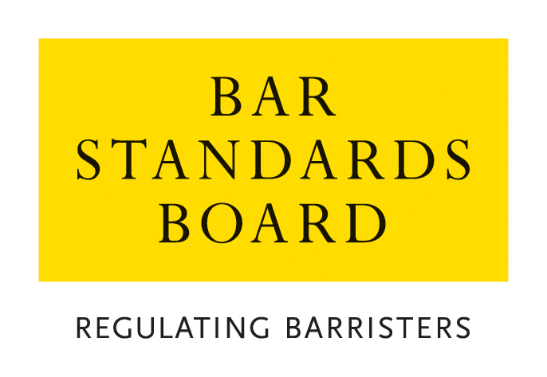
OISC Licensed Access - Registration or Renewal Form

This form is for use of Immigration Advice Agencies accredited at the Office of the Immigration Services Commissioner (OISC) Level 2 and/or Level 3.

This form is for registration on the Licensed Access licensing scheme operated by the Bar Standards Board or renewal of an existing licence issued by the Bar Standards Board.

Are you seeking registration or renewal of a BSB licence? | Registration / Renewal (delete as appropriate)

Name of Organisation:

Address:

Telephone Number:

Email Address:

Contact Name in Organisation:

Please provide the name(s) of your advisors and their level of accreditation (Level 2 and/or Level 3 only):

Level | Full Name
Level 2
Level 3

DECLARATION (to be signed by a member of the Governing Body of the Agency (ie a member of the Board of Directors, a Trustee, Chief Executive or equivalent).

- I confirm that the above named individuals are authorised (if a licence is issued by the Bar Standards Board) by the organisation to use the licensed access scheme on behalf of the organisation.

- I confirm that the information provided on this form is true to the best of my knowledge and that any change whether arising before a licence is granted or during the currency of a licence will be notified immediately to the Bar Standards Board.

- I understand that the organisation’s advisory level will be checked against the OISC website, and that any concerns regarding the registered level may be raised by the BSB with the OISC directly.

- I have read the Bar Council’s Privacy Statement and understand how the data I have provided will be handled.

Signed
Name
Position in Organisation
Date

PLEASE RETURN THE COMPLETED APPLICATION FORM WITH ACCOMPANYING DOCUMENTATION AND PAYMENT OF THE APPLICATION FEE TO:

authorisations@barstandardsboard.org.uk

Alternatively the completed application form can be posted to:

THE AUTHORISATIONS TEAM, REGULATORY OPERATIONS DEPARTMENT, THE BAR STANDARDS BOARD, 289-293 HIGH HOLBORN, LONDON WC1V 7HZ

The fee is non-refundable.

See https://www.gov.uk/government/organisations/office-of-the-immigration-services-commissioner
See https://www.barstandardsboard.org.uk/privacy-statement.html

